**PROJECT ANALYSIS**

1. USE-CASE LEVEL-0

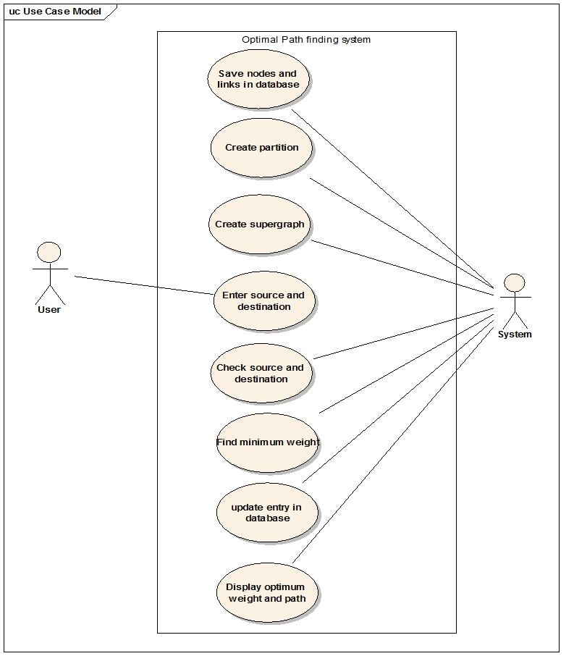

2. ACTIVITY DIAGRAM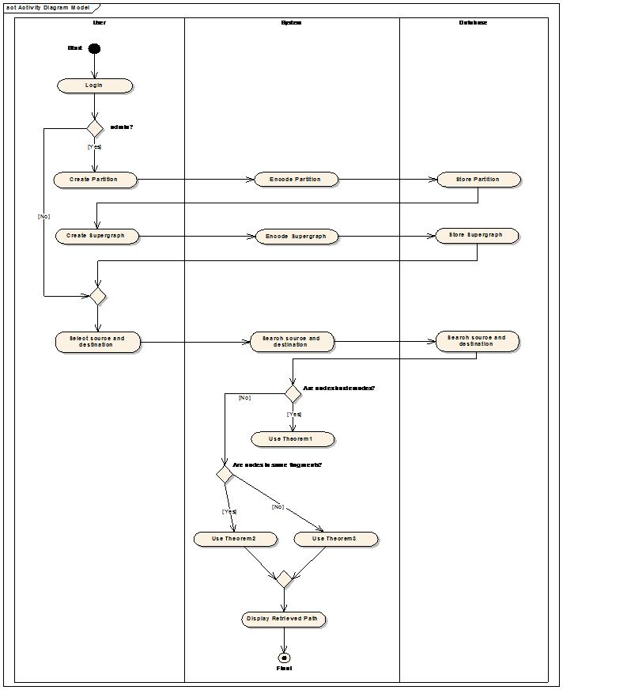

**PROJECT DESIGN**

1. DATAFLOW DIAGRAM

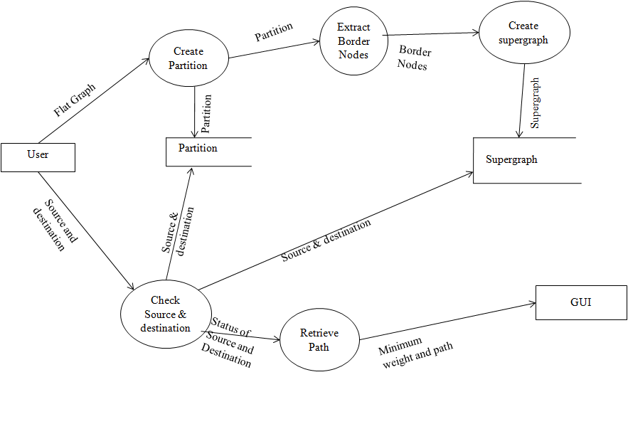

2. ENTITY-RELATIONSHIP DIAGRAM

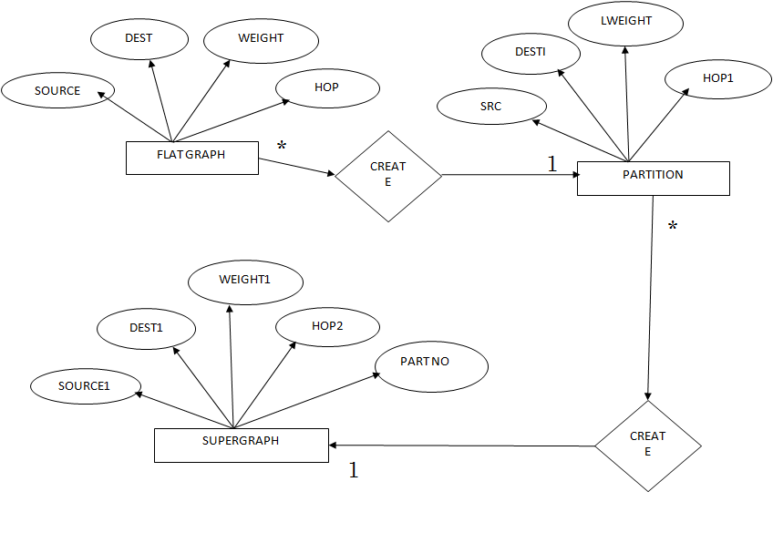

3. CLASS DIAGRAM

4. SEQUENCE DIAGRAM

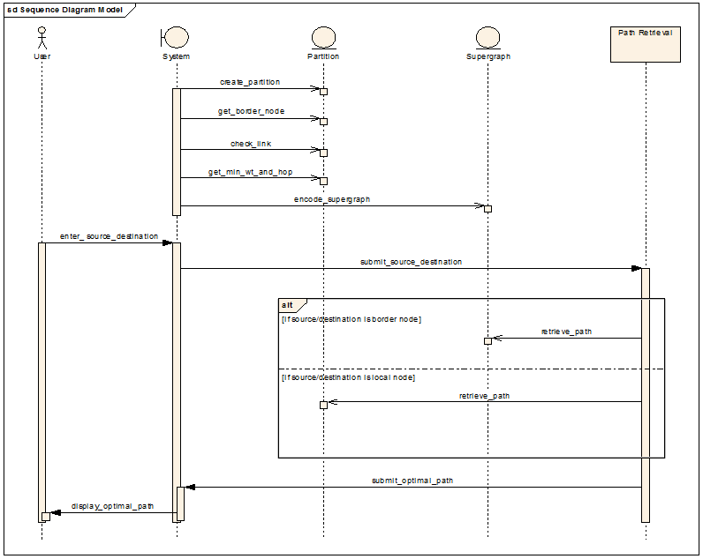

5. COLLABORATION DIAGRAM

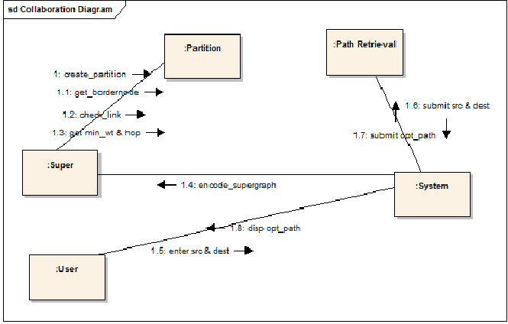

6. STATE TRANSITION DIAGRAM 

7. DEPLOYMENT DIAGRAM

